

**CSE423: Computer Graphics**

**Lab Assignment 1**

**Important Instructions for the Assignment:**

● Before starting this assignment, please ensure you have installed the mentioned OpenGL libraries in your System.

● The skeleton code is provided for completing the tasks, or you can design your own.

● For submission, **paste your source code along with the screenshots of the output in a single doc file and submit it in the google classroom/form provided by lab faculty.**

● The deadline for submission is to be strictly maintained. **Late submissions will not be accepted.**

**● You must attend the lab viva for each assignment. Otherwise, you won’t get any lab marks for that assignment.**

● Any form of plagiarism will automatically cancel your assignment and will be awarded with a **-100%** mark.. Please refrain from such activities.

**Task 1: Building a House in Rainfall**

i. Draw a **house with a raindrop** using the base primitives: points, lines, or triangles. You can use **ONLY *GL_POINTS***, ***GL_LINES,*** or ***GL_TRIANGLES*** for designing this house. A diagram has been provided as an example. **You can modify the house design to your liking.**

ii. It has been raining unwantedly for the last few days, so let’s control its direction by designing a key that will change the direction of the rain when clicked (slightly bending the rainfall). Design this functionality such that the **left arrow** will gradually bend the rain to the left and the **right arrow** will gradually bend the rain to the right.

iii. Formulate two more keys(**assign whatever key you like**); pressing one will gradually change the skin colour from dark to light simulating night to day, and the other will change it from light to dark simulating day to night . You must also consider the rain and the house visibility in different background colours.

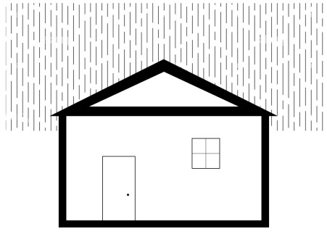

**Task 2: Building the Amazing Box**

Design a box with the following functionalities and ensure they all work independently and in any combination. Check out the gifs along with instructions for better understanding.

i. The **right button** click on a mouse will generate random movable points with different colours going **in any random direction diagonally**. For instance, if a point is generated at (0,0), it can go to (-1, 1), (-1, -1), (1,1), or (1, -1), and so on. The points should be spawned where the **right button** click will be given in the box and the colour and direction of movement should be random.

ii. Pressing the “**up arrow**” key on the keyboard will increase the speed of all the points generated so far and pressing the “**down arrow**” key on the keyboard will decrease the speed.

iii. The **left button** click on a mouse will make the points blink i.e. if a point is in red, it will go background colour(here it’s black) and return to red, and this transition should take place within a second while the transition cycle goes on.

iv. Pressing the “**Spacebar”** on the keyboard should freeze all the points and none of the above functionalities will work when frozen. The same “**Spacebar**” should unfreeze them.

**Submission guideline**: You have to submit it in the classroom. Please follow the submission instructions carefully. Failure to follow will be subject to a mark penalty (20% to 50%).